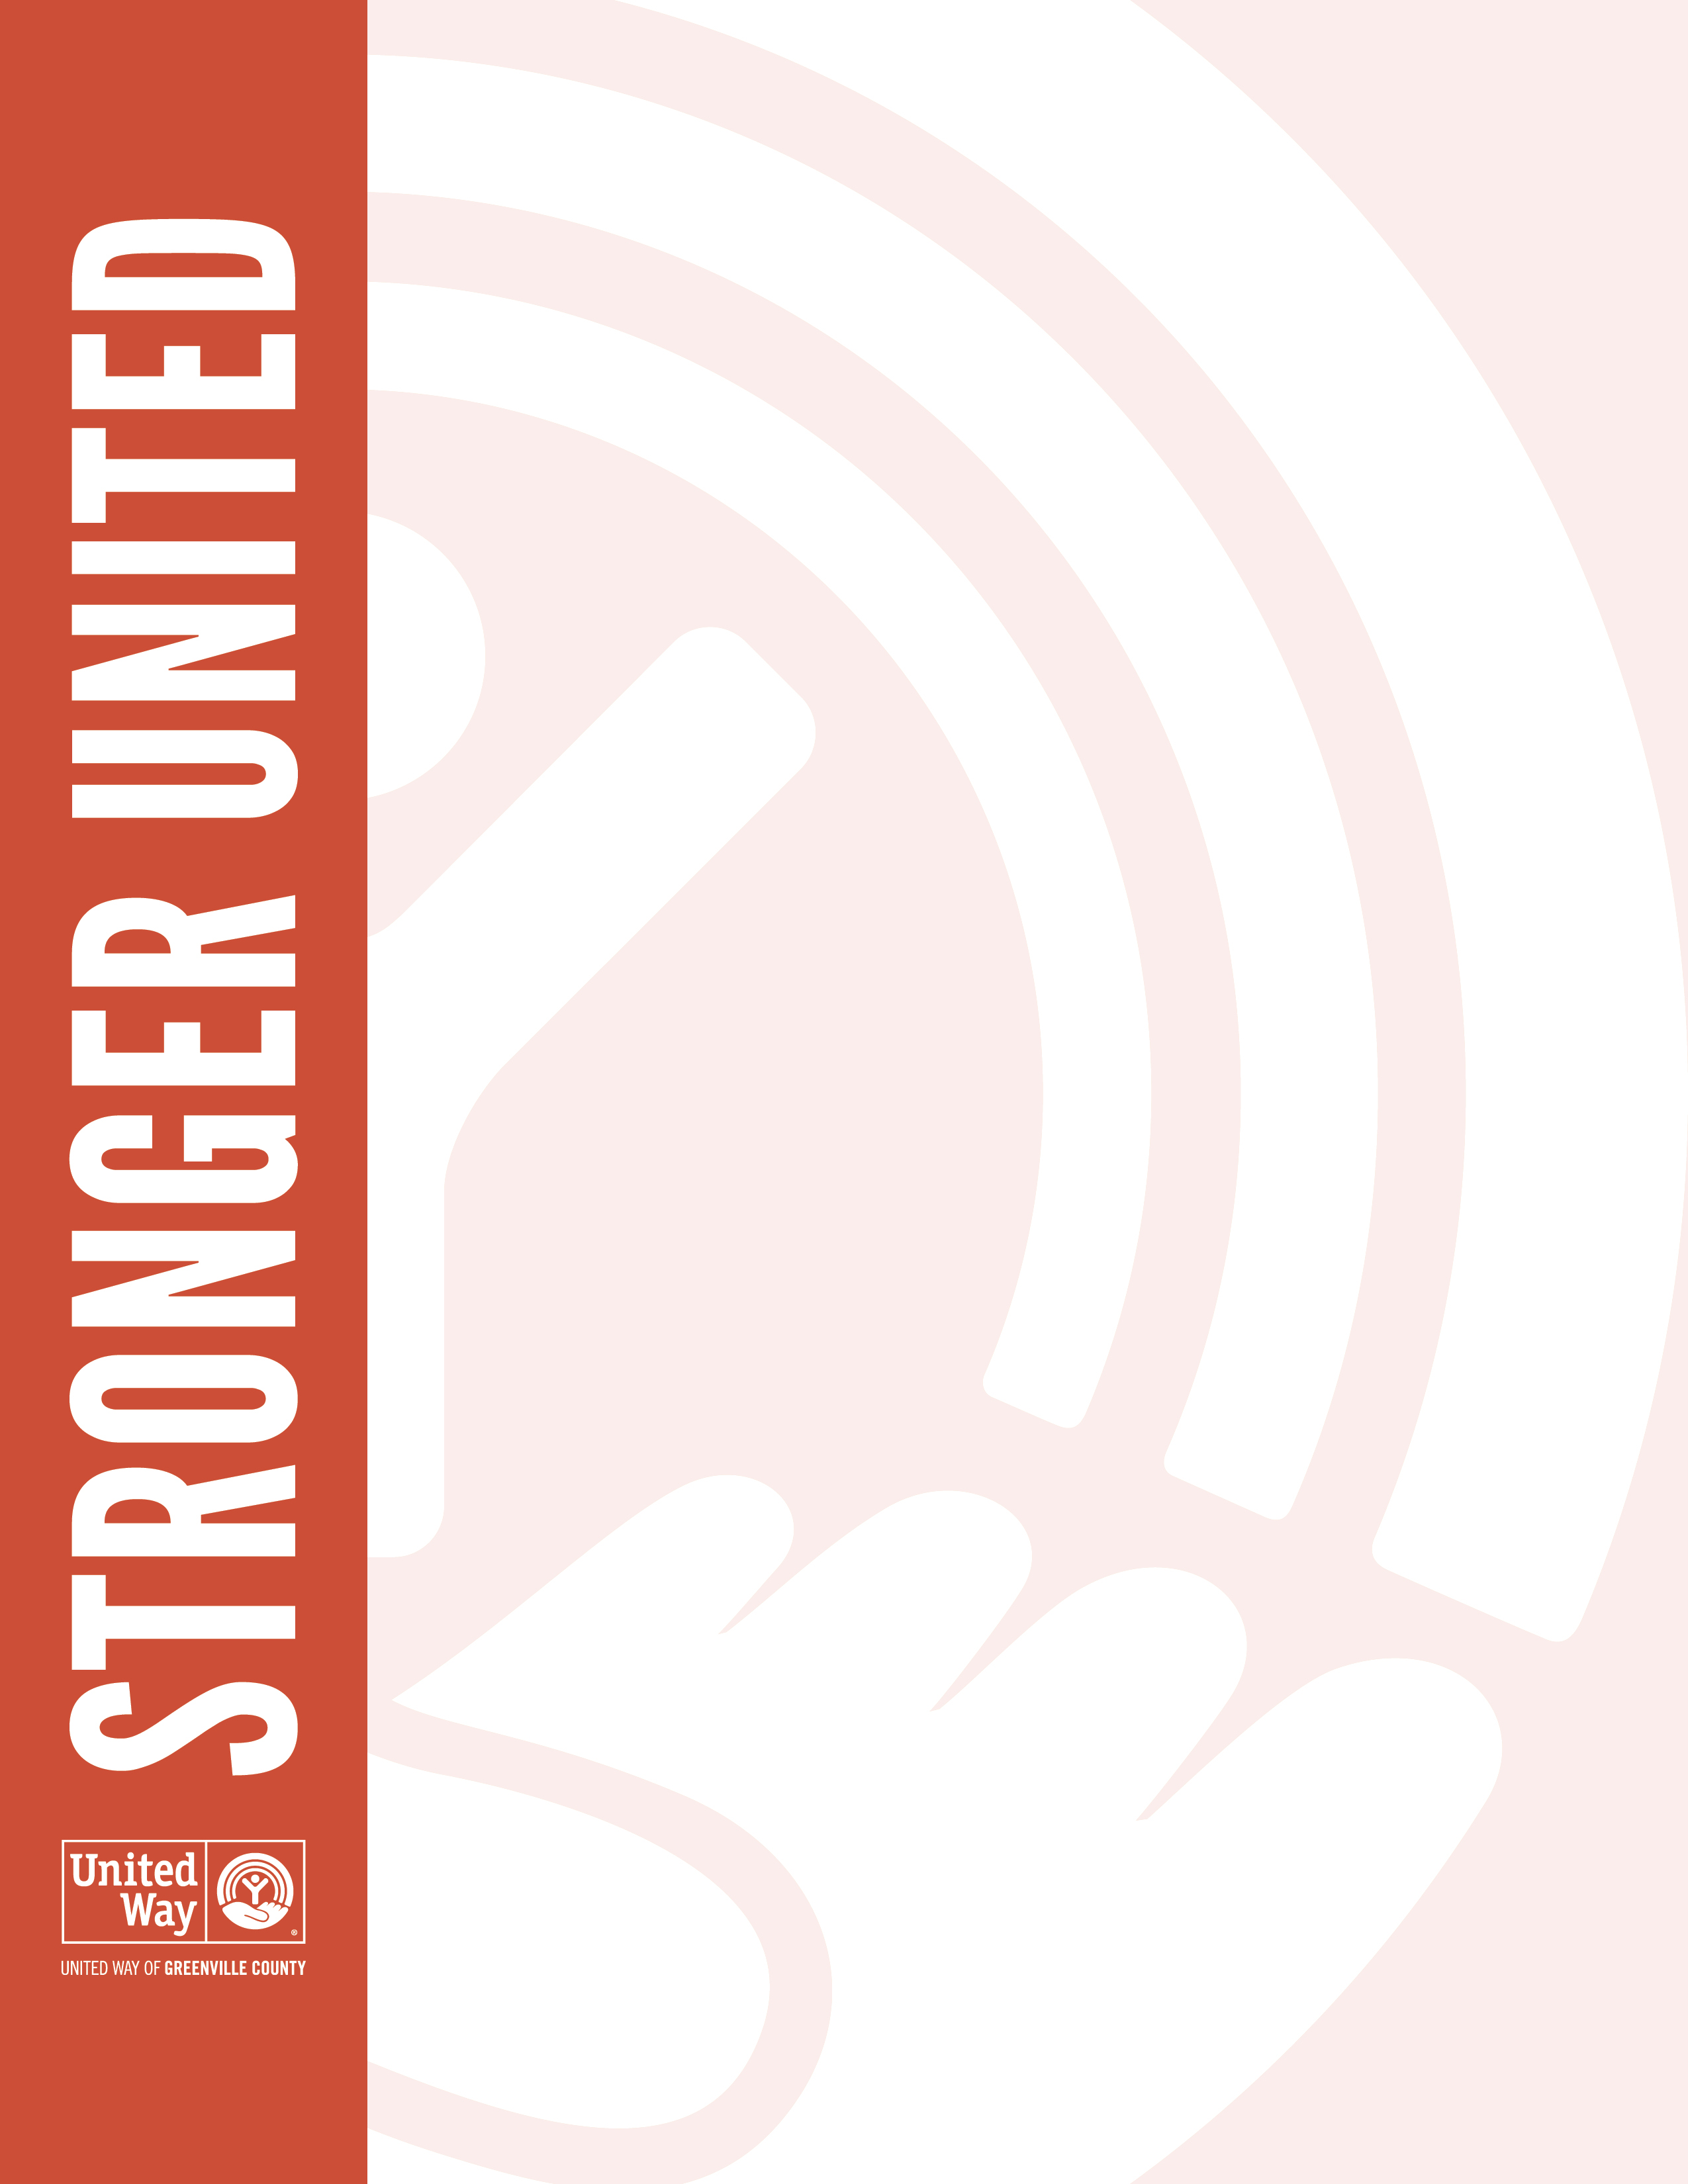
Dear {Content.Contact.FirstName},

I want to personally thank you for supporting United Way and its mission to build a better Greenville County for all. Each dollar you pledge to United Way makes its way into the hands of more than 70 nonprofit partners and 100+ local programs that drive real change. Your generous gift will touch the lives of thousands of local families fighting to break down the barriers to success.

This year, [Company Name] raised $[employee campaign dollars] to support United Way of Greenville County and the community most of us call home. We should be proud of our collective efforts to care for our families, friends and neighbors—those we know and many we may never meet.

This is what it looks like to be Stronger United. Thanks again for showing Greenville County how much [Company Name] cares.

Sincerely,
CEO Name

