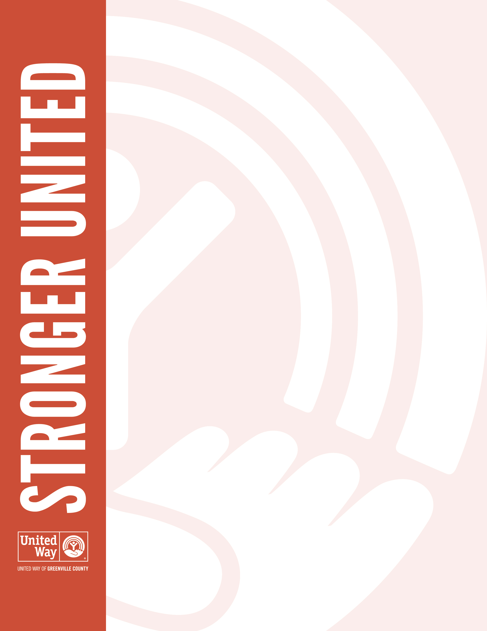
Dear [First Name],

I hope you will join the [employee percentage]% of your coworkers who have pledged to our United Way of Greenville County campaign. Your support will change the lives of thousands of families and individuals here in our community.

Our campaign runs until [campaign end date], and I hope you will consider joining us. Each dollar you pledge to United Way makes its way into the hands of more than 70 nonprofit partners and 100+ local programs making a real impact in our community.

Help us show Greenville County how much [Company Name] cares. We truly are Stronger United.

Sincerely,
[CEO signature]

