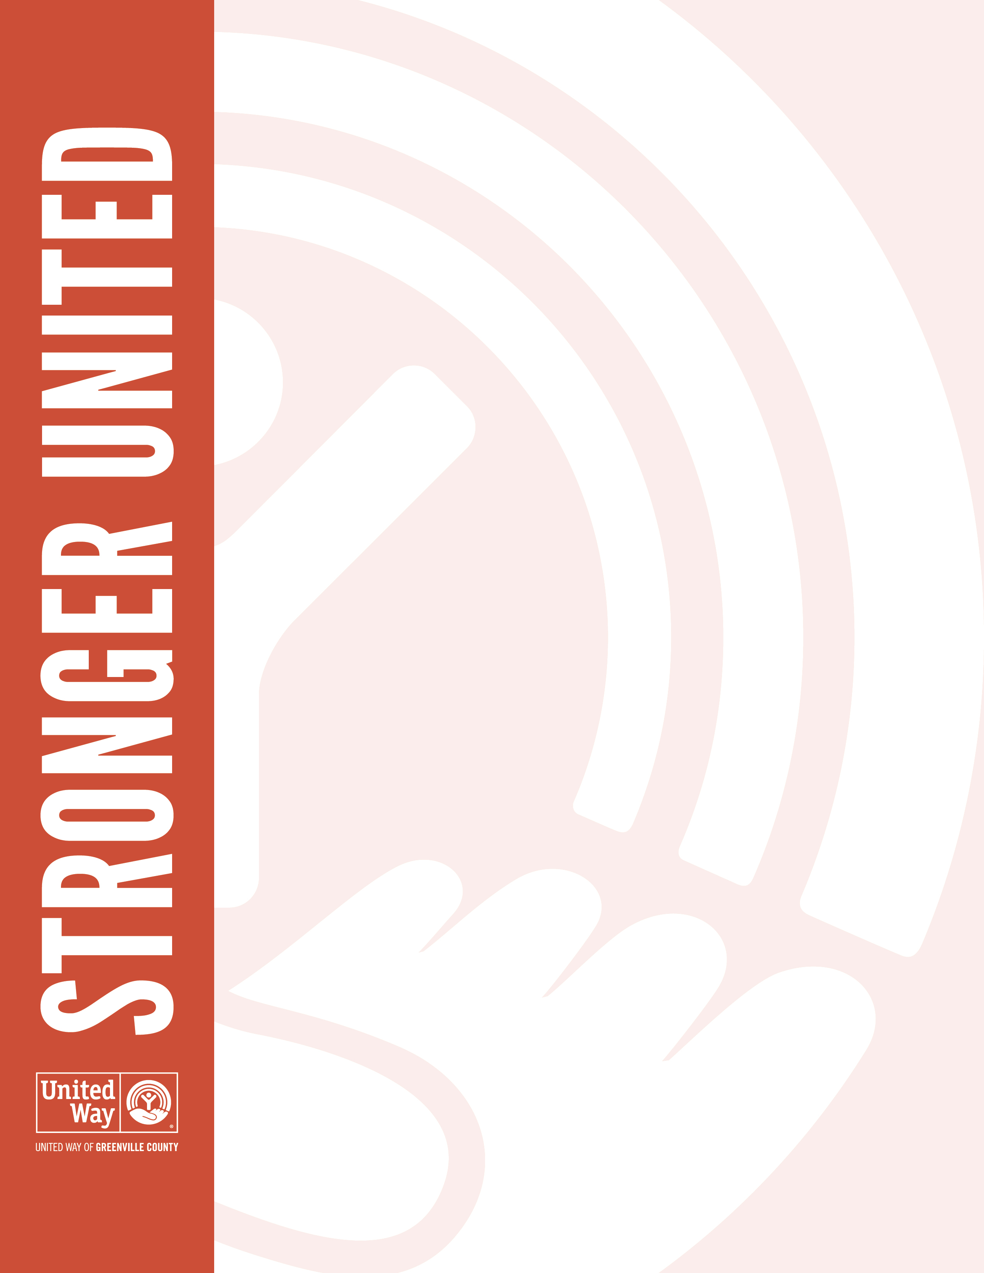
Dear [First Name],

Our United Way of Greenville County campaign ends [campaign end date], and we would love to have your support. Please consider making a pledge and joining [Company Name] as we show Greenville County how much we care.

Each dollar you pledge will make a real difference in our community, changing the lives of families and individuals struggling with housing, transportation, education, financial stability and so much more.

Join us by making your pledge by [campaign end date]. We are Stronger United.

Sincerely,
[CEO signature]

