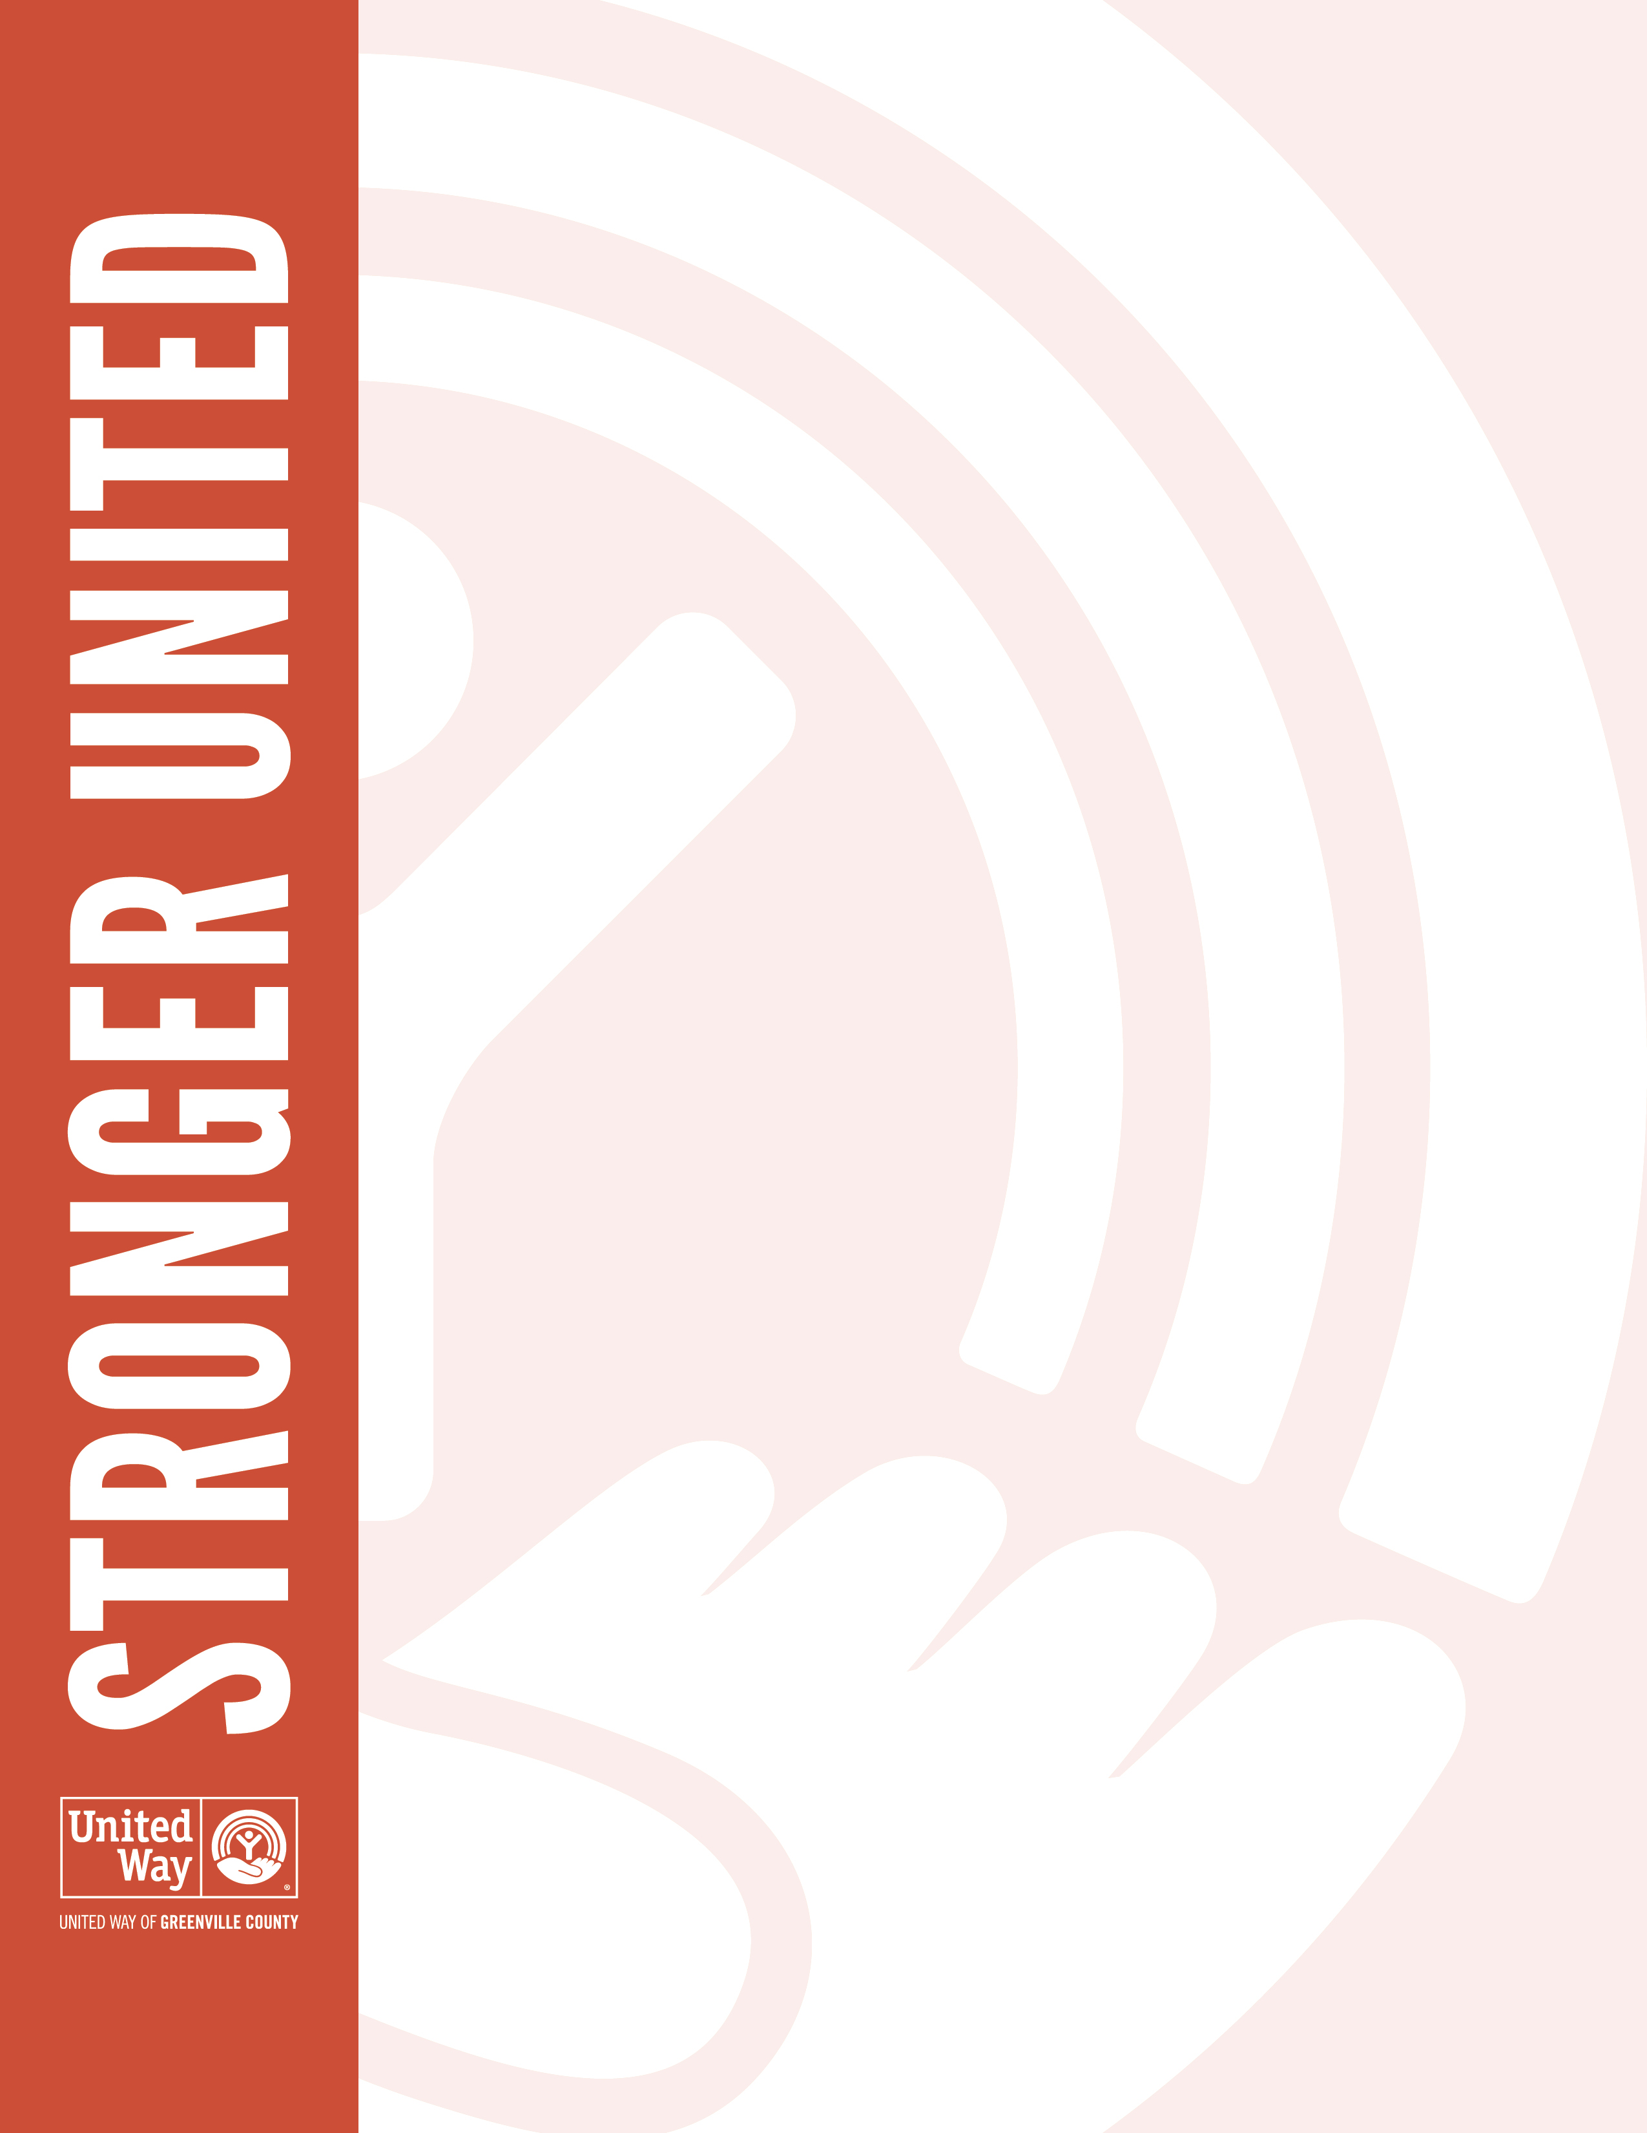
Dear [First Name],

I want to personally thank you for giving generously at the leadership level this year through our United Way of Greenville County campaign. With your Palmetto Society gift, you are joining other generous donors across Greenville County to strengthen the quality of life for all in our community. Passionate people like you are leading the way to a brighter tomorrow.

Our campaign was a success, with a total of $[employee campaign dollars] raised to support United Way of Greenville County and the community we call home. I want to thank you for showing Greenville County the compassion and caring spirit we see every day at [Company Name]. Together, we are changing lives. We truly are Stronger United.

Sincerely,
[CEO signature]

