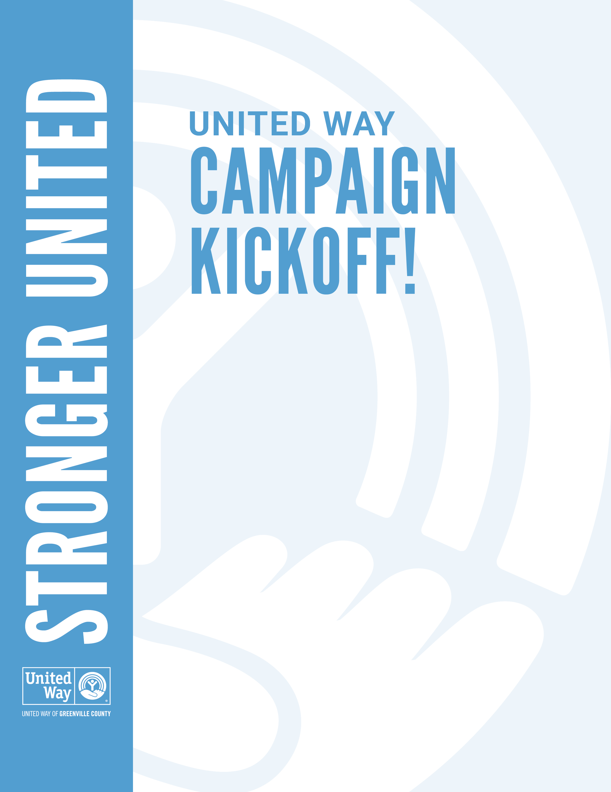­­

**LOCATION:** First Floor Breakroom

**DATE:** Tuesday, July 30

**TIME:** 2:30 PM

Join us in the breakroom for our annual United Way of Greenville County kickoff meeting featuring a special guest from the Boys and Girls Club.

Please let Sally know if you can attend or have any questions.

See you there!