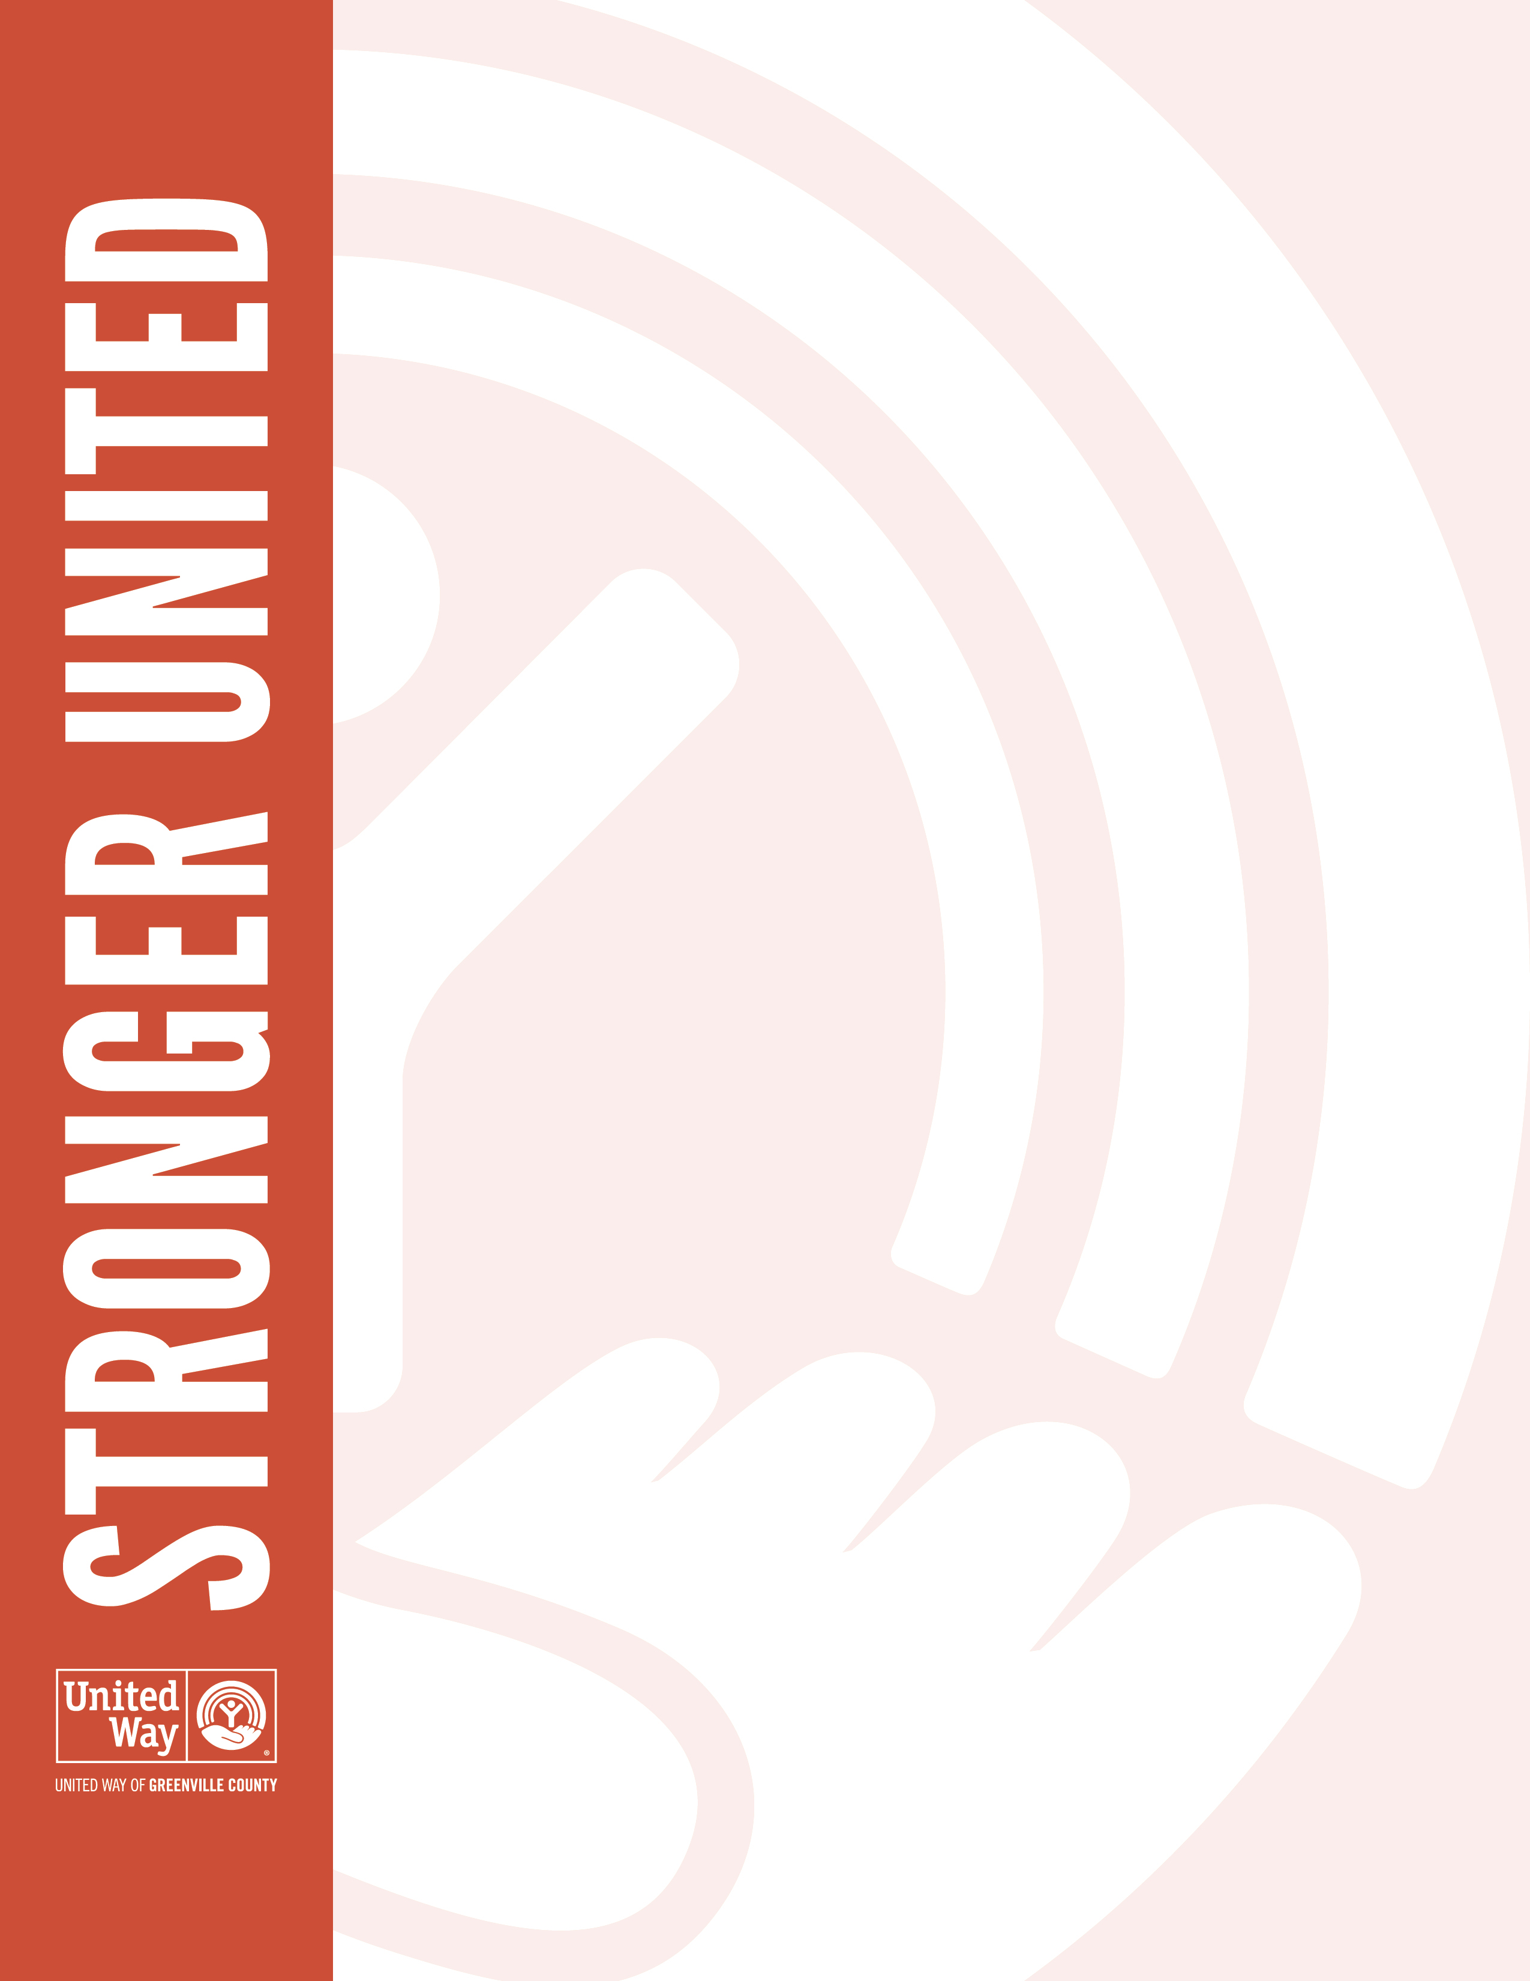
Dear [First Name],

We’re thrilled to have you join us for this year’s United Way of Greenville County campaign. Your gift will make a real difference in the lives of families and individuals here in our community—contributing to a better Greenville County for all.

United Way funds more than 70 agencies and 100 local programs fighting to break down the barriers to success, from transportation and affordable housing to education, job training and so much more.

Every dollar we raise and every hour spent volunteering works toward helping our neighbors, coworkers and people we may never meet reach their full potential. As we kick off our 2019 giving campaign, we will be sharing more about the work United Way of Greenville County is doing to build a better future for everyone in our community.

We can truly make a difference and change lives here in our community. Thank you for fighting for our future. We are Stronger United.

Sincerely,
[Name & Signature]

